

School of Computer Science and Artificial Intelligence
Lab Assignment # 2.2
Program : B. Tech (CSE)
Specialization :
Course Title : AI Assisted coding
Course Code :

Semester II

Academic Session : 2025-2026

Name of Student : R.Akash Reddy

Enrollment No. : 2403A51L30

Batch No. 51
Date :13-01-2026

Submission Starts here
Task-1: Cleaning Sensor Data
- Scenario:
- You are cleaning IoT sensor data where negative values are invalid.
- Task:
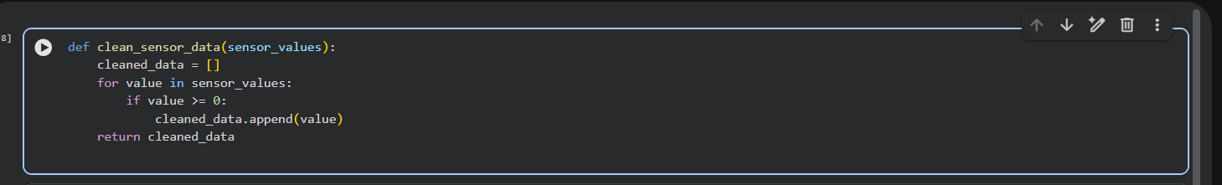
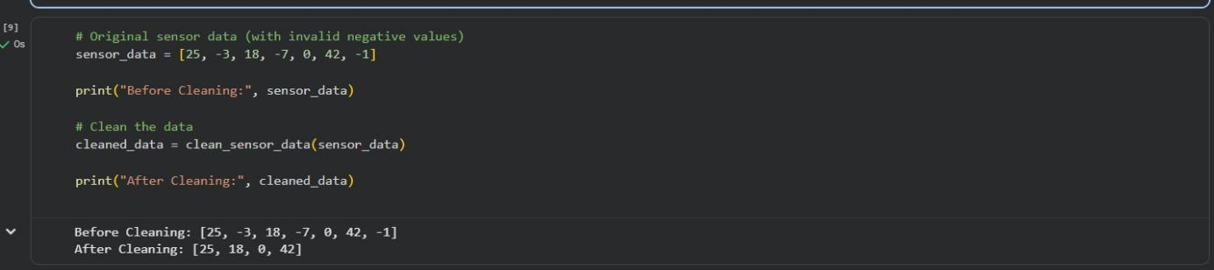
Use Gemini in Colab to generate a function that filters out all negative numbers from a list.

Line-by-Line Explanation

- def clean_sensor_data(sensor_values):
  - Defines a function named clean_sensor_data
  - sensor_values is the input list containing sensor readings (may include negative values)

cleaned_data = []
  - Creates an empty list
  - This list will store only valid (non-negative) sensor values

for value in sensor_values:

  - Loops through each value in the input sensor list

  - Processes one sensor reading at a time

if value >= 0:
  - Checks whether the sensor value is greater than or equal to zero
  - This condition ensures that negative values are ignored

cleaned_data.append (value)
  - Adds the valid sensor value to the cleaned_data list

return cleaned_data
  - Returns the final list containing only valid sensor readings

▶ Example Execution Explanation
sensor_data = [25, -3, 18, -7, 0, 42, -1]

  - Input list contains both valid and invalid sensor values
  - ​
cleaned_data = clean_sensor_data (sensor_data)
  - Function removes all negative values
✅ Output:
[25, 18, 0, 42]

# Task 2: String Character Analysis
  - Scenario:
You are building a text-analysis feature.
  - Task:
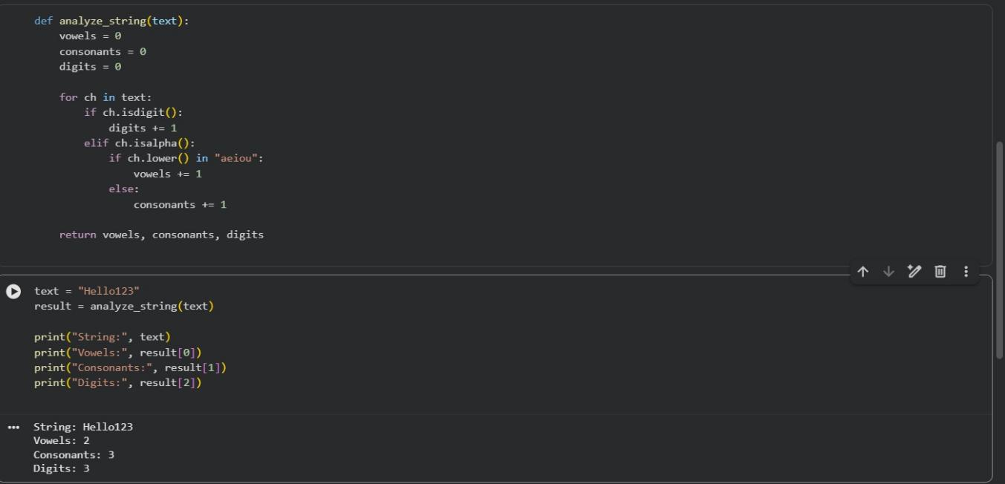
Use Gemini to generate a Python function that counts vowels, consonants, and digits in a string.

Explaination:
1 def analyze_string(text):
  - Defines a function named analyze_string
  - text is the input string that will be analyzed

2 vowels = 0, consonants = 0, digits = 0
  - Initializes three counters
  - These variables store the count of vowels, consonants, and digits
3 for ch in text:
  - Loops through each character in the input string
  - Processes one character at a time

4 if ch.isdigit():
  - Checks if the character is a number (0–9)
  - If true, the digit counter is increased 5digits += 1:
  - Increments the digit count by 1

6 elif ch.isalpha():
  - Checks if the character is an alphabet
  - Ignores spaces and special characters
7 if ch.lower() in "aeiou":
  - Converts the character to lowercase
  - Checks if it is a vowel (a, e, i, o, u)

8 vowels += 1
  - Increments the vowel count if the condition is true

9 else:
  - If the alphabet is not a vowel, it must be a consonant

🔟 consonants += 1
  - Increments the consonant count

11 return vowels, consonants, digits
  - Returns all three counts as a tuple

#Task 3: Palindrome Check – Tool Comparison
  - Scenario:
You must decide which AI tool is clearer for string logic.
  - Task:
Generate a palindrome-checking function using Gemini and Copilot, then compare the results.

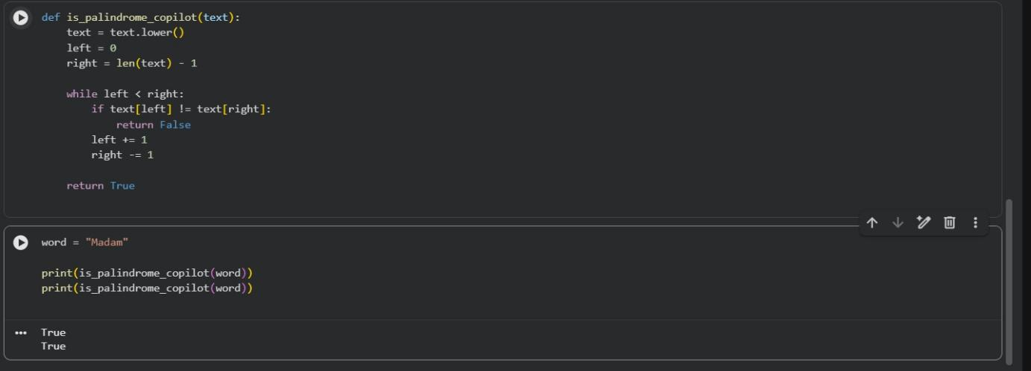

Explaination:
1 def is_palindrome_gemini(text):
  - Defines a function to check whether a string is a palindrome
  - text is the input string 2 text = text.lower()
  - Converts all characters to lowercase
  - This avoids case mismatch (e.g., Madam vs madam) 3 text[::-1]
  - Reverses the string using Python slicing
  - [::-1] means read the string from end to start 4 return text == text[::-1]
  - Compares the original string with its reversed version
  - Returns True if both are the same, otherwise False def is_palindrome_copilot(text):
  - Defines a function to check if a string is a palindrome 2 text = text.lower()
  - Converts the string to lowercase for case-insensitive comparison 3 left = 0
  - Points to the first character of the string 4 right = len(text) - 1
  - Points to the last character of the string 5 while left < right:
  - Loop runs until both pointers meet in the middle 6 if text[left] != text[right]:
  - Compares characters from both ends
  - If they are not equal, the string is not a palindrome
- return False
  - Immediately stops and returns False if mismatch is found 8 left += 1
  - Moves the left pointer forward 9 right -= 1
  - Moves the right pointer backward
🔟 return True
  - If all characters match, the string is a palindrome

#Task 4: Code Explanation Using AI

    - Scenario:
You are reviewing unfamiliar code written by another developer.
- Task:
Ask Gemini to explain a Python function (prime check OR palindrome check) line by line.
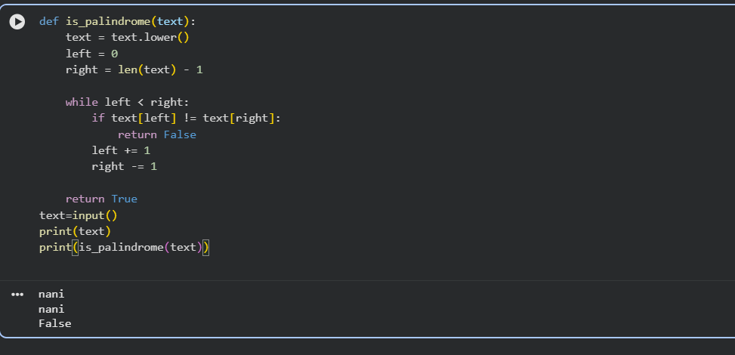

Explaination:

def is_palindrome(text):
  - Defines a function named is_palindrome
  - Takes a string text as input

text = text.lower()
  - Converts all characters in the string to lowercase
  - Ensures case-insensitive comparison (e.g., Madam = madam)

left = 0
  - Initializes a pointer to the first character of the string

right = len(text) - 1
  - Initializes a pointer to the last character of the string

while left < right:
  - Starts a loop that runs until both pointers meet in the middle

if text[left] != text[right]:
  - Compares characters at the left and right pointers
  - If they are not equal, the string is not a palindrome

return False
  - Immediately exits the function if a mismatch is found

left += 1
  - Moves the left pointer one step forward

🔟 return True

right -= 1
  - Moves the right pointer one step backward

    - If all character pairs match, the string is a palindrome

